Setup Slideshow Module

1. Go to *Content*
2. Add Content
3. Choose *Slideshow*
4. Fill in the Title and slide details

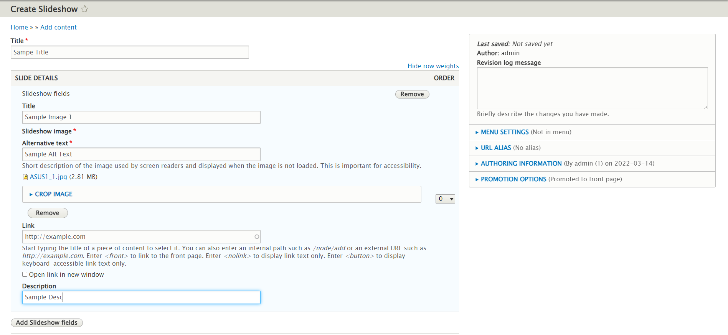

1. To add more slide, click *Add Slideshow Fields* and repeat step 4
2. Click *save*
3. Go to *Structure* -> *Block* *layout* -> *featured* *bottom* *first*
4. Click *Place Block*
5. Search for *Slideshow* and *Place* *Block*

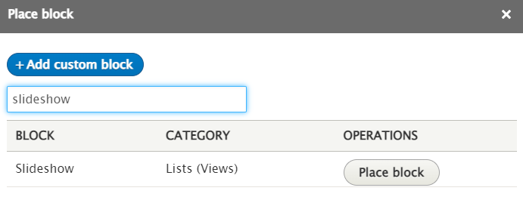

1. Configure block as shown below

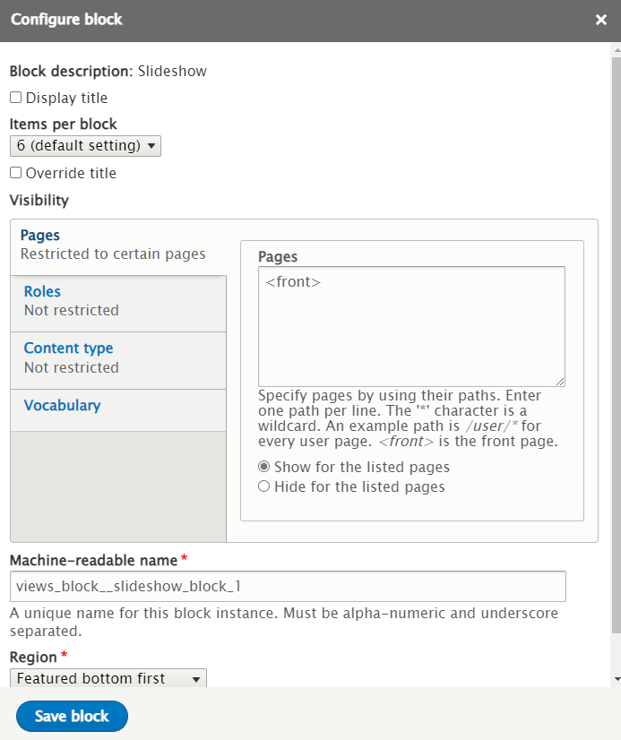

1. Click *Save block*
2. The *Slideshow* should appear in the home page